Regular Wavy Shapes

Definition
# Source: AI Source: Provided by: [Data Path: Persons Table -> ID Column: 1, Name_En Column: Motasem Essam] -> From: [ChatGPT] on [7/25/2026]
A Regular Wavy Shape is a wavy shape whose wave pattern follows a consistent, repeating, or highly uniform structure.
Its waves may have equal or systematically repeating:
- Amplitudes
- Wavelengths or spacing
- Curvatures
- Direction changes
- Repeated geometric features
The term regular wavy shape is mainly descriptive, rather than a universally standardized mathematical classification.
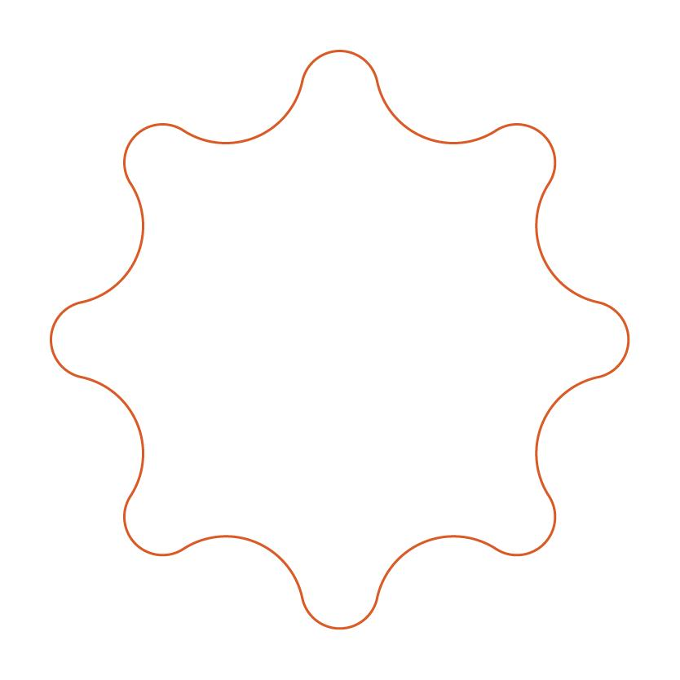
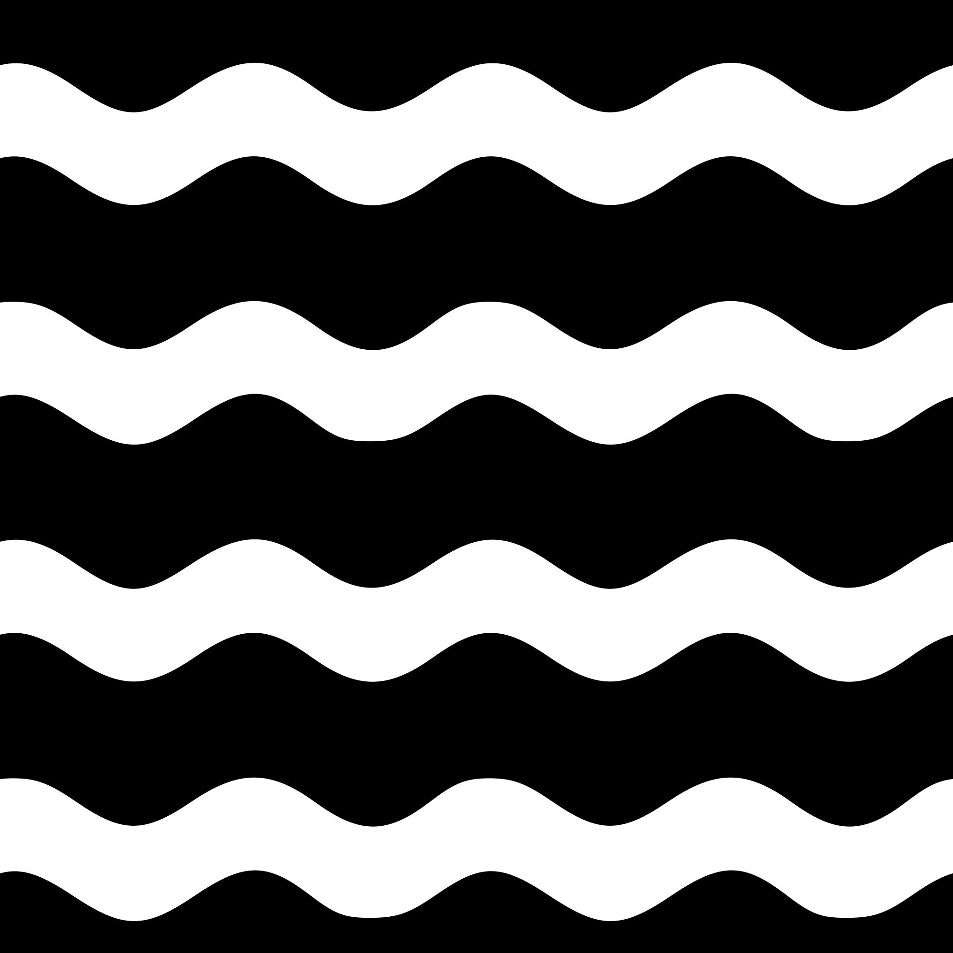
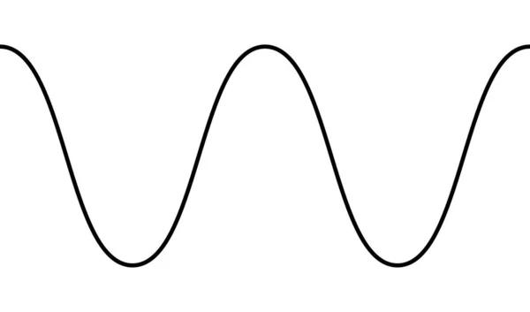
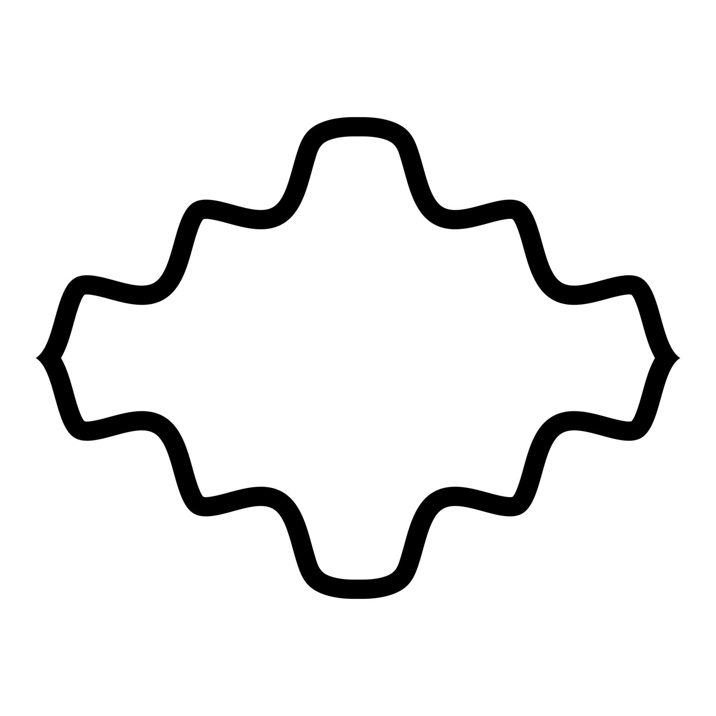

Fundamental Concept
# Source: AI Source: Provided by: [Data Path: Persons Table -> ID Column: 1, Name_En Column: Motasem Essam] -> From: [ChatGPT] on [7/25/2026]
The main idea is repetition and consistency.
For example, a regular wavy boundary might look conceptually like:

~~~ ~~~ ~~~
~~ ~~ ~~ ~~ ~~ ~~
~~ ~~ ~~
The individual waves follow a predictable pattern rather than changing randomly.
A regular wavy shape can be open or closed.

Main Characteristics
# Source: AI Source: Provided by: [Data Path: Persons Table -> ID Column: 1, Name_En Column: Motasem Essam] -> From: [ChatGPT] on [7/25/2026]
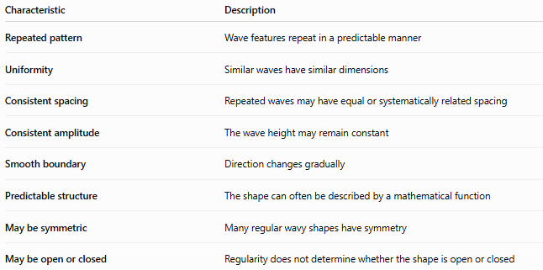
Characteristic | Description
Repeated pattern | Wave features repeat in a predictable manner
Uniformity | Similar waves have similar dimensions
Consistent spacing | Repeated waves may have equal or systematically related spacing
Consistent amplitude | The wave height may remain constant
Smooth boundary | Direction changes gradually
Predictable structure | The shape can often be described by a mathematical function
May be symmetric | Many regular wavy shapes have symmetry
May be open or closed | Regularity does not determine whether the shape is open or closed

Basic Structure
# Source: AI Source: Provided by: [Data Path: Persons Table -> ID Column: 1, Name_En Column: Motasem Essam] -> From: [ChatGPT] on [7/25/2026]
A regular wavy pattern can be represented using a sinusoidal function such as
$$y=Asin⁡\left(Bx+C\right)+D$$
where:
- $A$= amplitude
- $B$= controls the frequency
- $C$= phase shift
- $D$= vertical shift
The wavelength is
$$λ=\frac{2π}{∣B∣}$$
for the standard sinusoidal form.
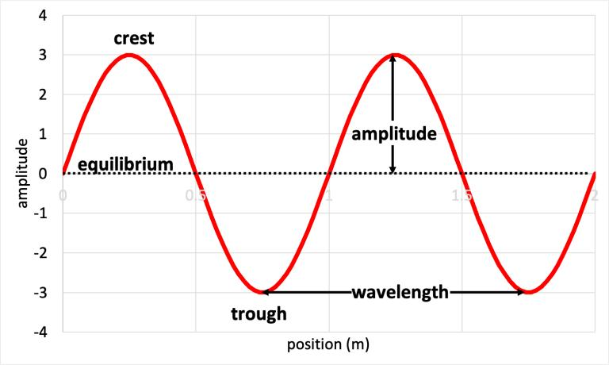
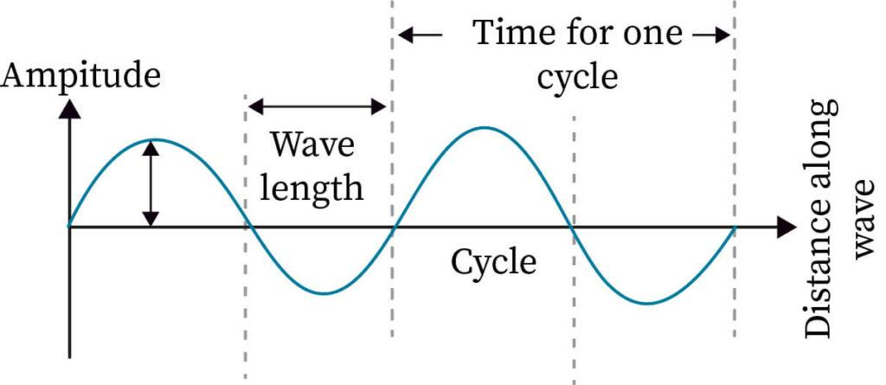
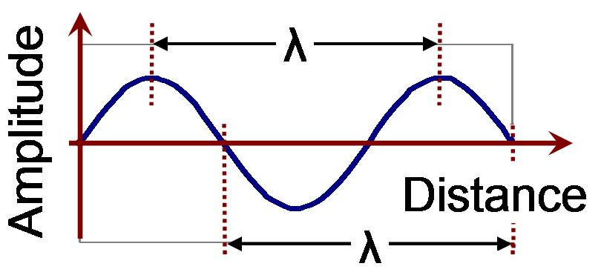
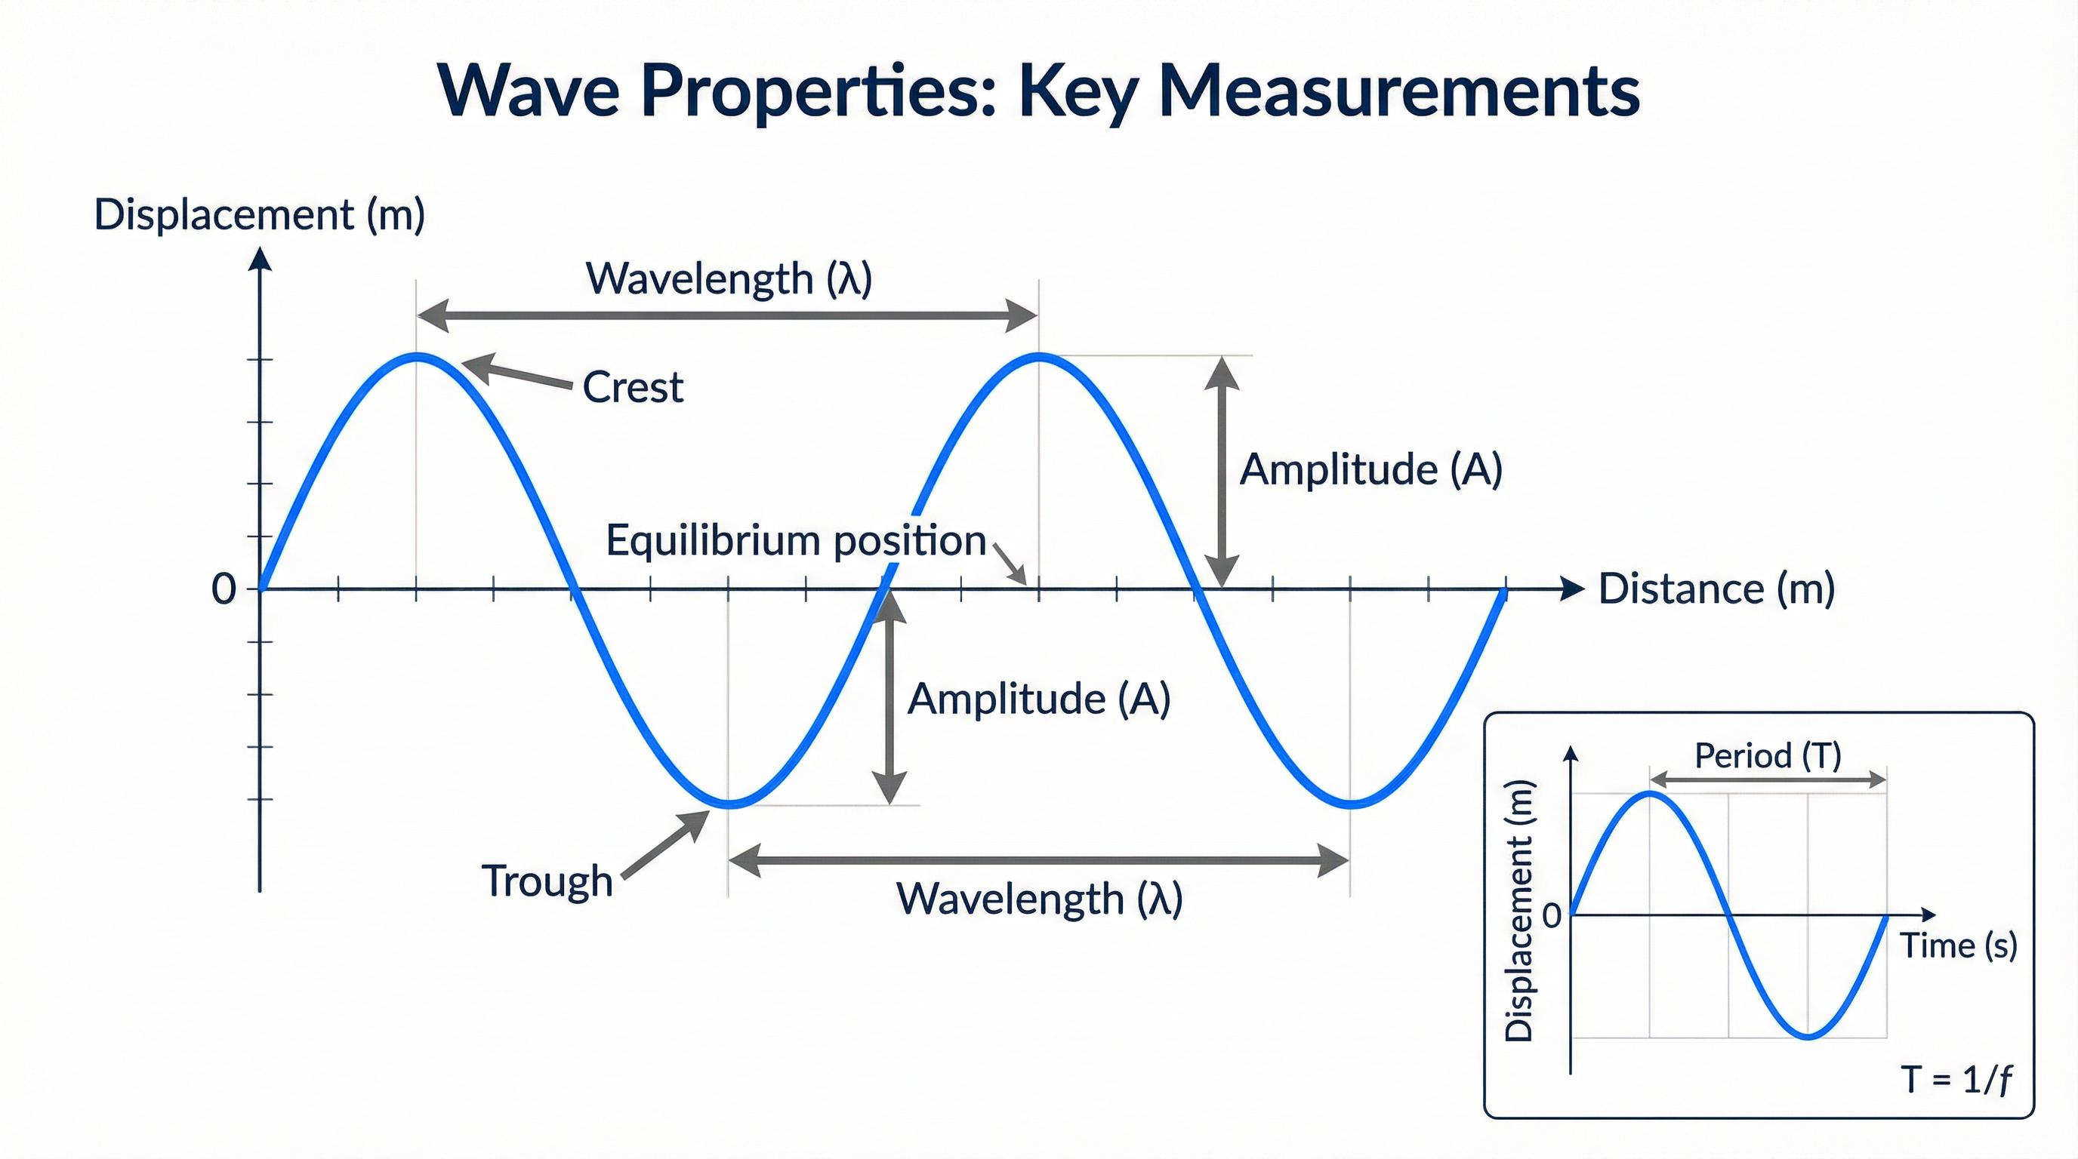
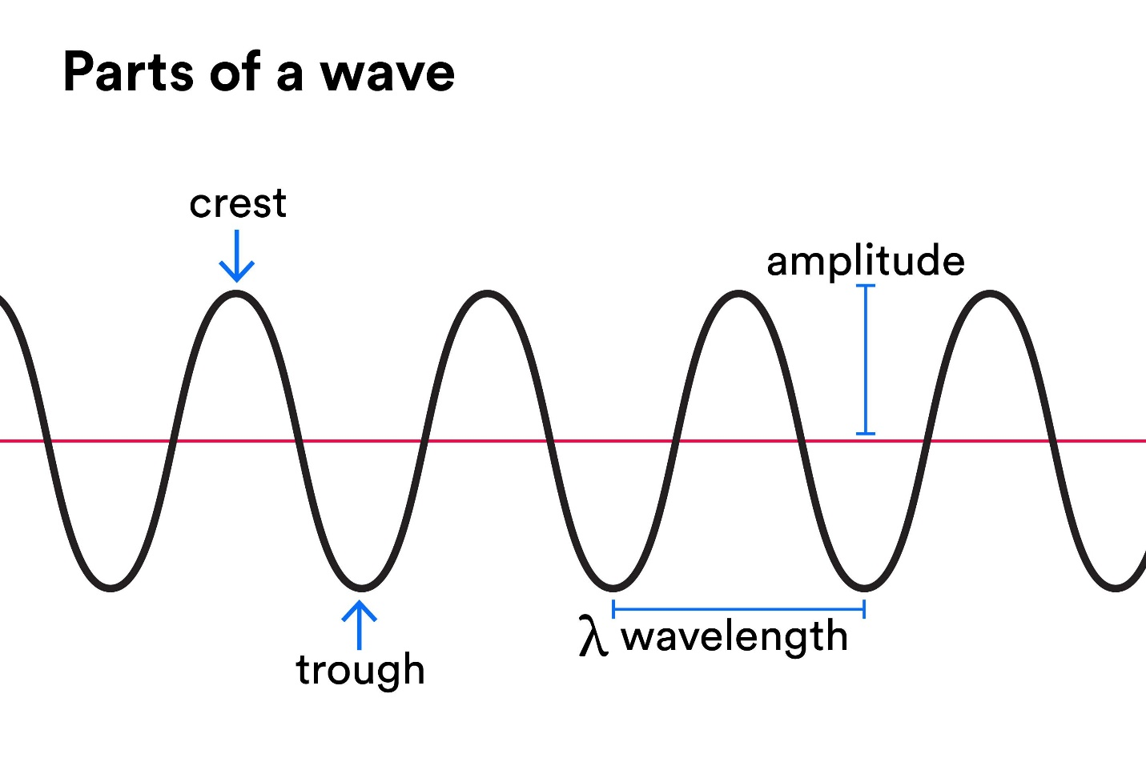

Types of Regular Wavy Shapes
# Source: AI Source: Provided by: [Data Path: Persons Table -> ID Column: 1, Name_En Column: Motasem Essam] -> From: [ChatGPT] on [7/25/2026]
Regular wavy shapes can be described according to their structure.

1-Regular Open Wavy Shapes
# Source: AI Source: Provided by: [Data Path: Persons Table -> ID Column: 1, Name_En Column: Motasem Essam] -> From: [ChatGPT] on [7/25/2026]
A Regular Open Wavy Shape is an open wavy path with a repeating pattern.
Example:
~~~ ~~~ ~~~ ~~~
~~~~ ~~~~ ~~~~
It has two endpoints and does not enclose an area by itself.
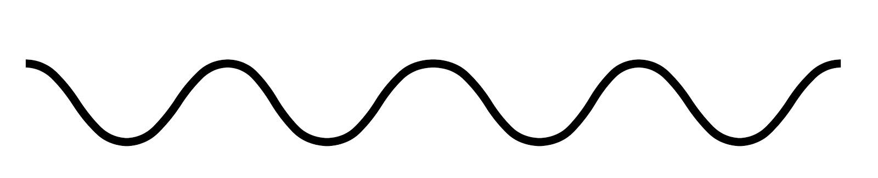
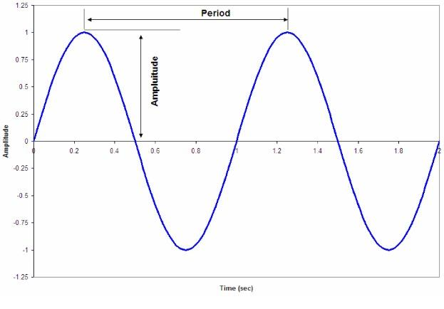
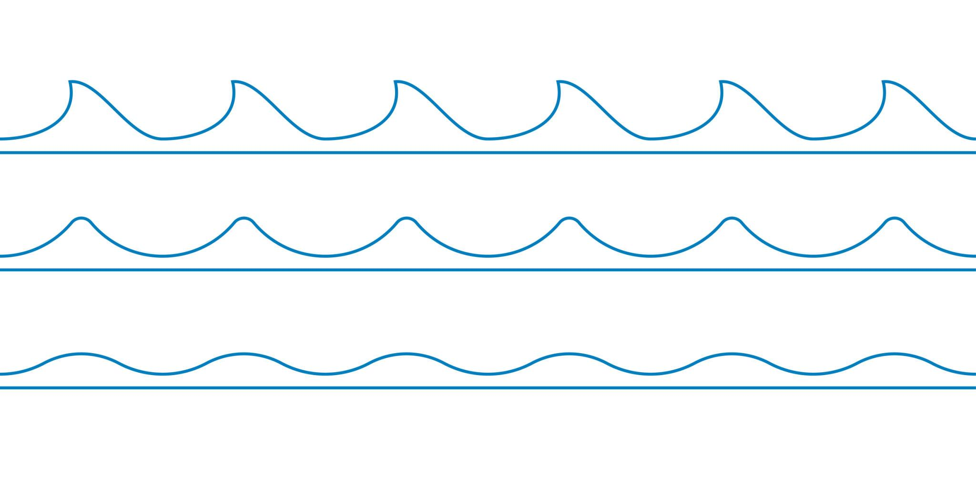
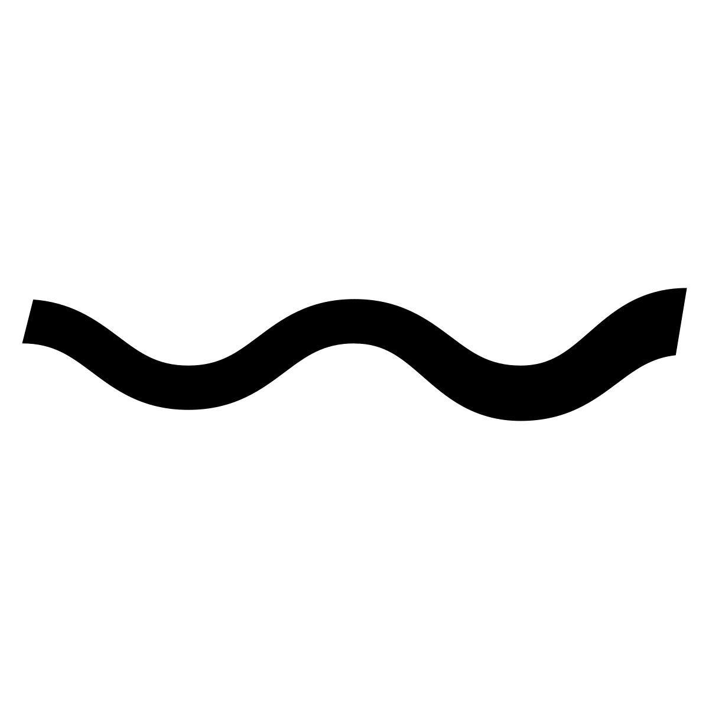
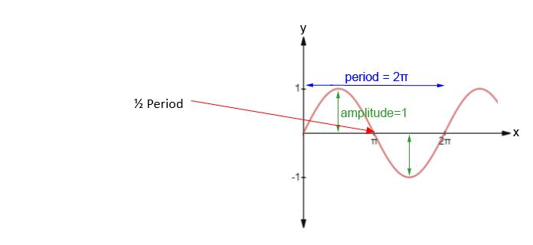

2-Regular Closed Wavy Shapes
# Source: AI Source: Provided by: [Data Path: Persons Table -> ID Column: 1, Name_En Column: Motasem Essam] -> From: [ChatGPT] on [7/25/2026]
A Regular Closed Wavy Shape has a closed boundary with a repeating wave pattern.
It has:
- No endpoints.
- A continuous boundary.
- An enclosed region.
- Repeated wave features.
A radial representation can be written as
$$r=R+Asin⁡\left(nθ\right)$$
where $n$controls the number of repeated wave cycles around the boundary.
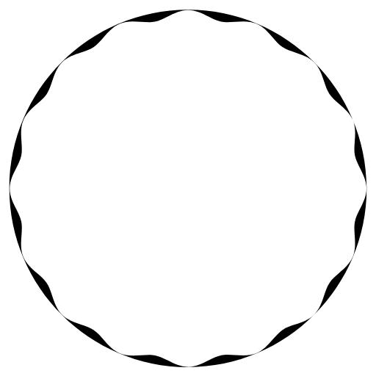
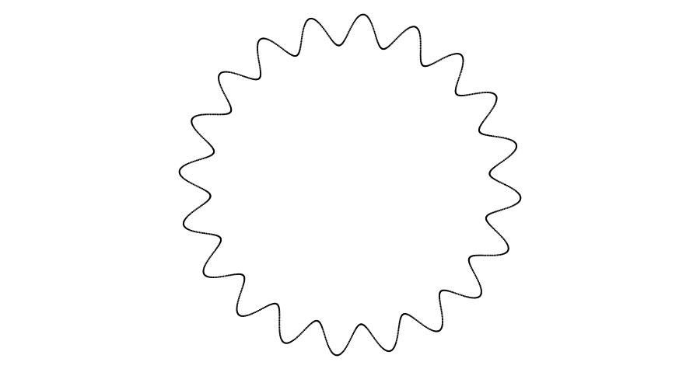
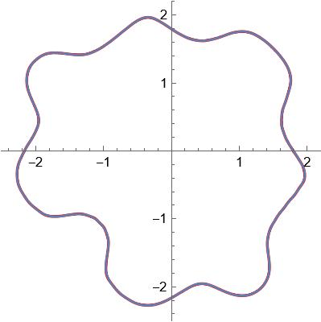
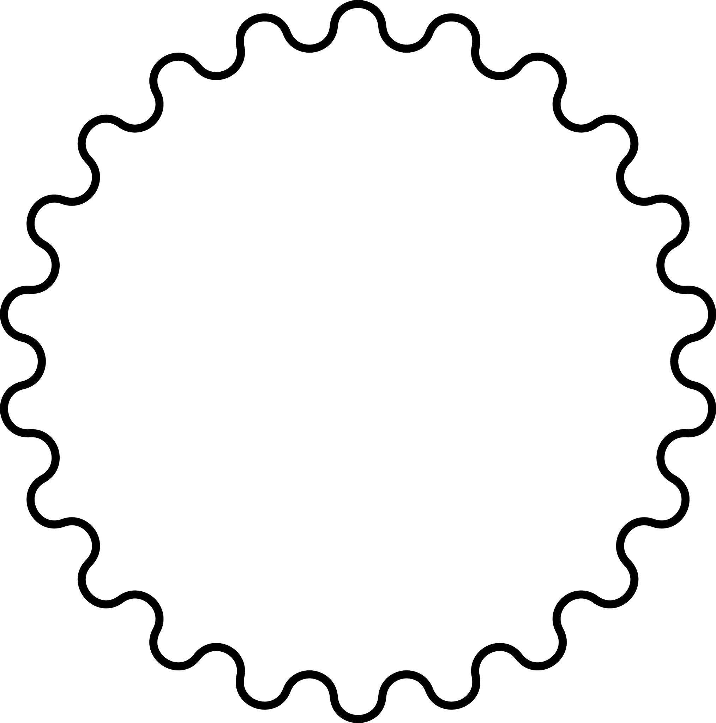
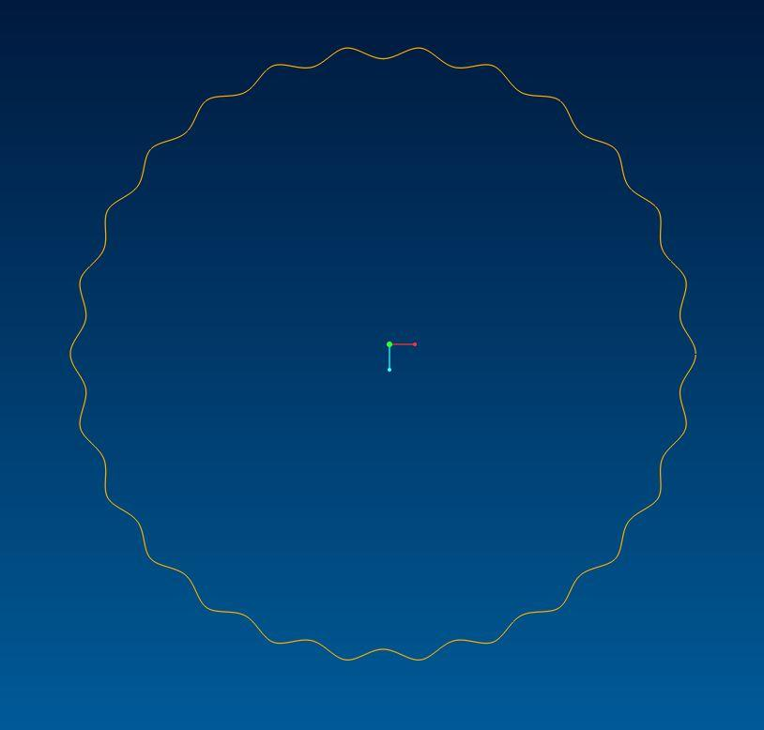

3-Regular Symmetric Wavy Shapes
# Source: AI Source: Provided by: [Data Path: Persons Table -> ID Column: 1, Name_En Column: Motasem Essam] -> From: [ChatGPT] on [7/25/2026]
A Regular Symmetric Wavy Shape combines regular repetition with symmetry.
For example, each wave may be mirrored across an axis:

~~~
~~ ~~
~~ ~~
~~ ~~
~~ ~~
~~~
The repeated structure can produce:
- Reflection symmetry.
- Rotational symmetry.
- Multiple symmetry axes.
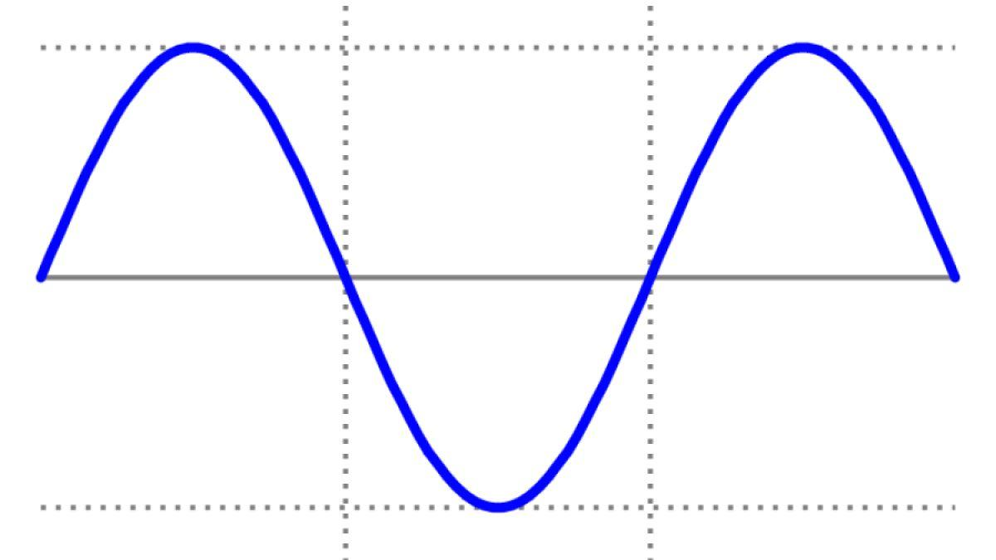

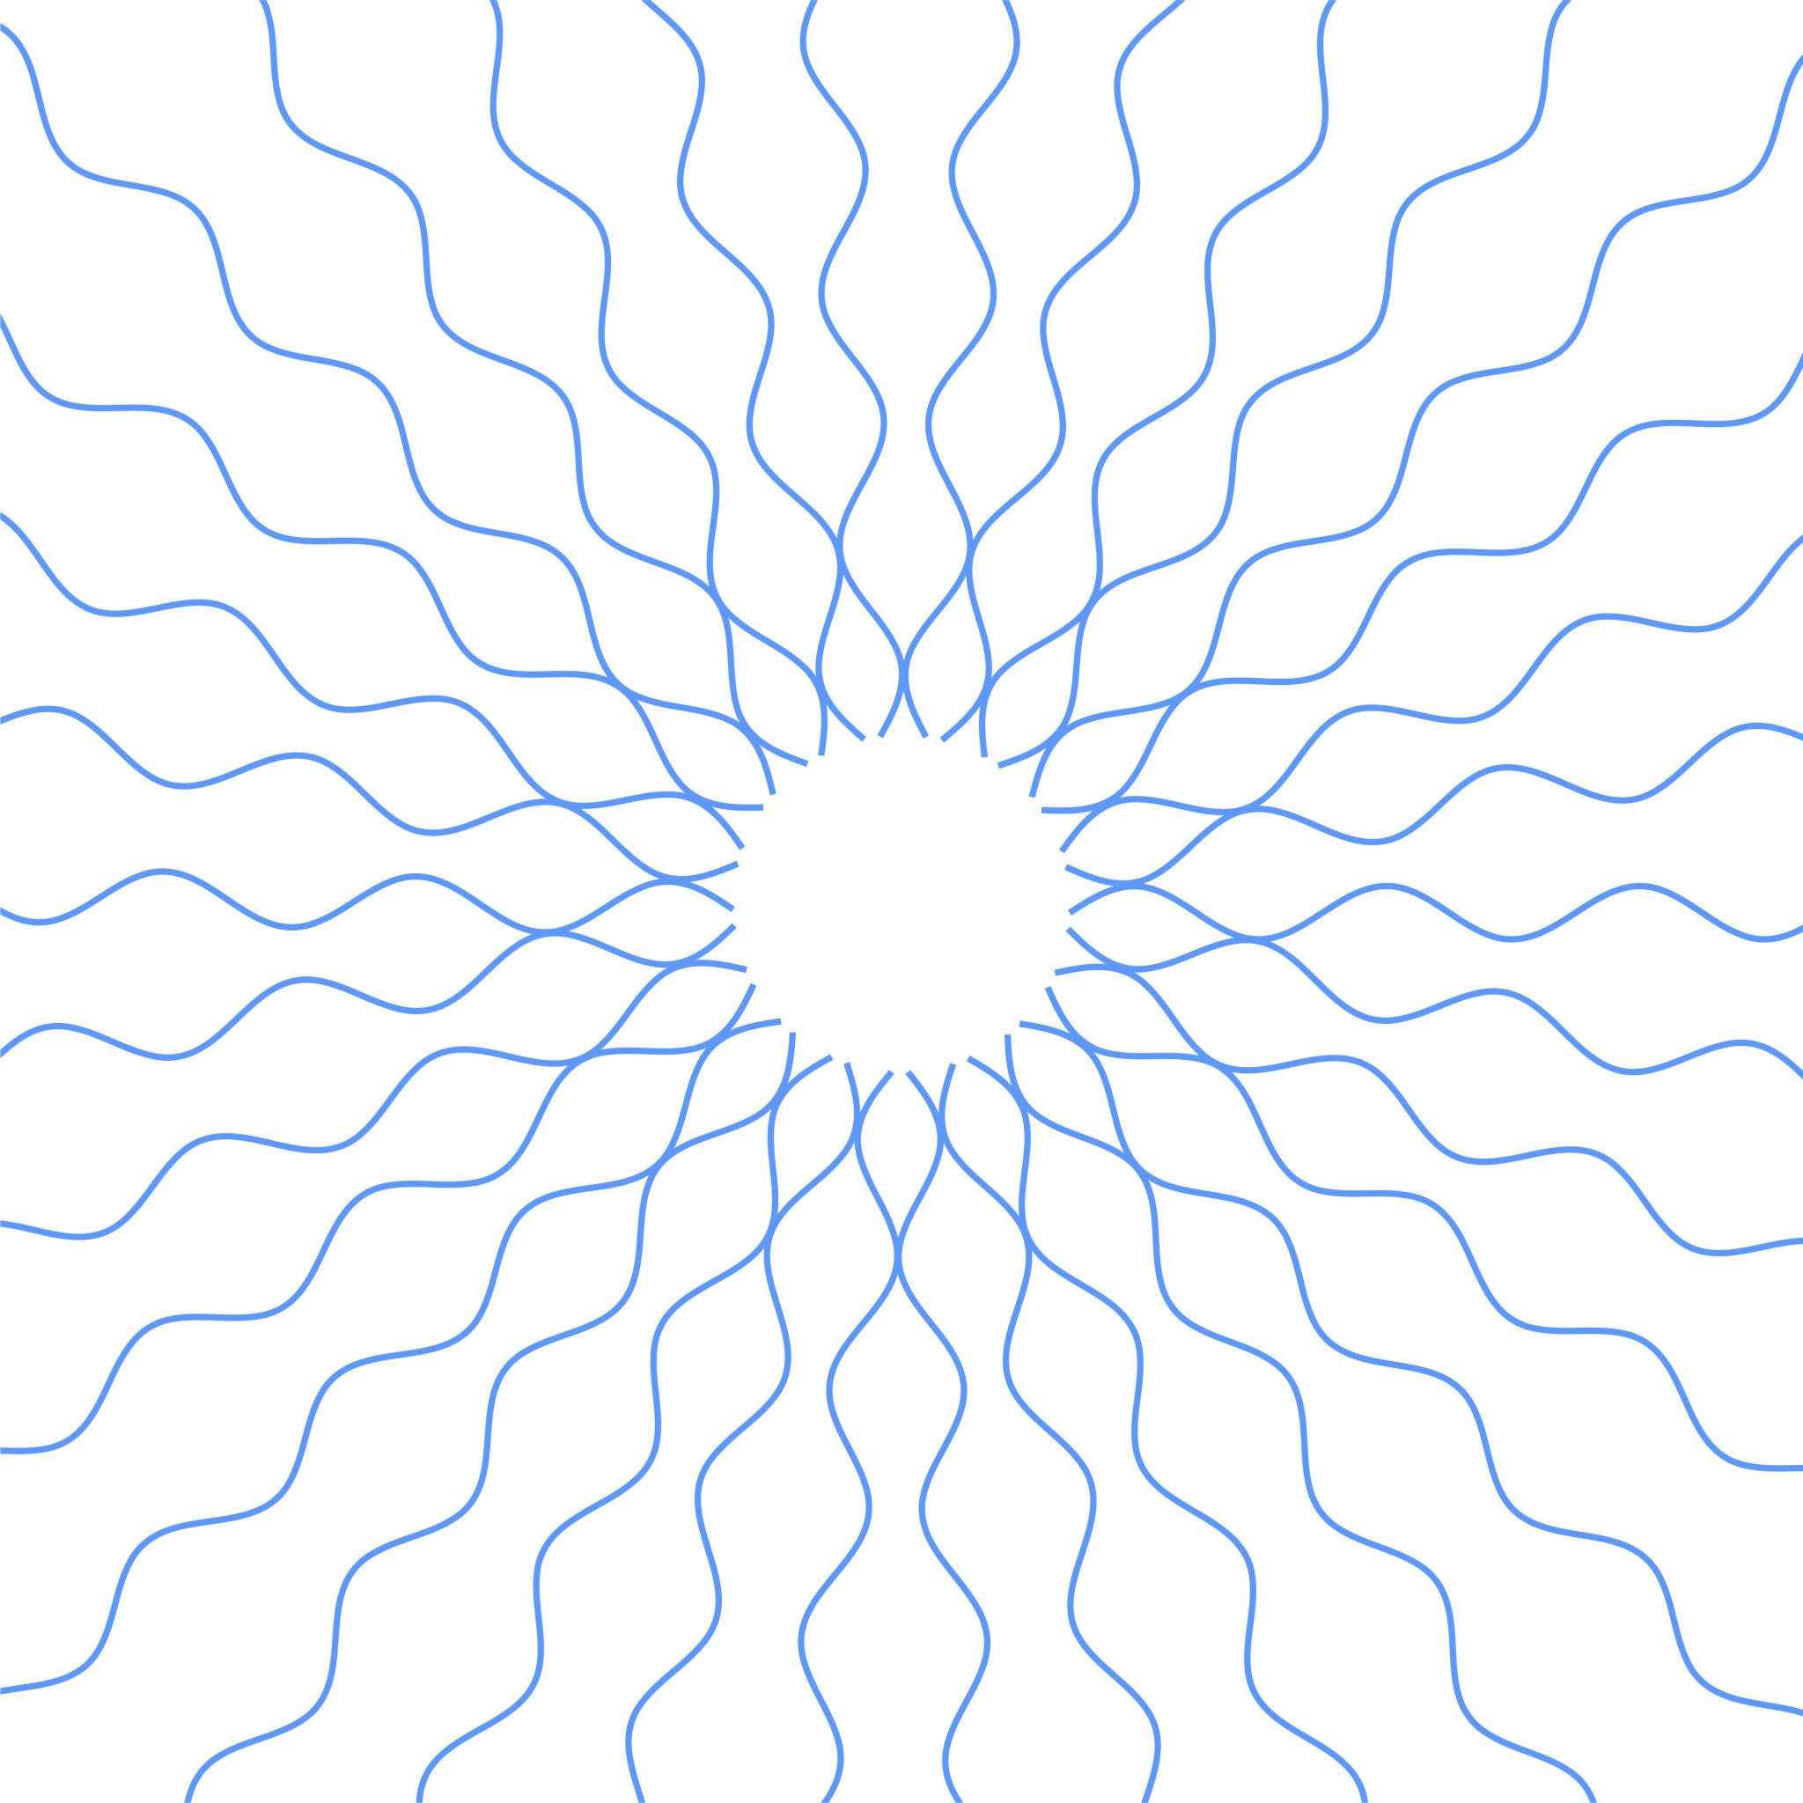
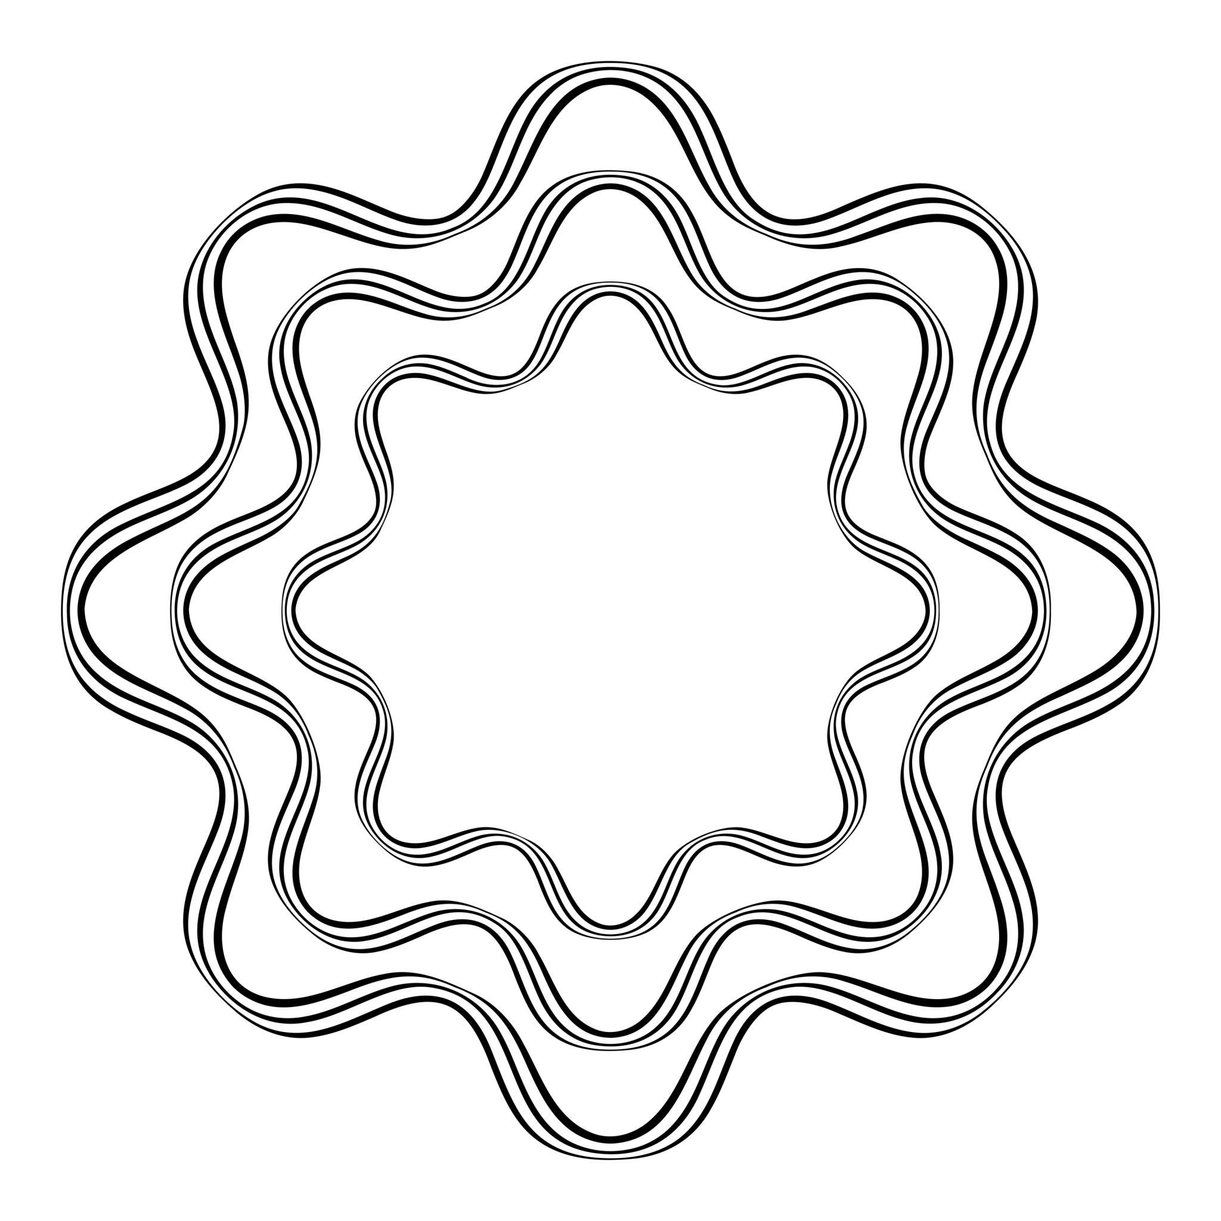

4-Regular Periodic Wavy Shapes
# Source: AI Source: Provided by: [Data Path: Persons Table -> ID Column: 1, Name_En Column: Motasem Essam] -> From: [ChatGPT] on [7/25/2026]
A Regular Periodic Wavy Shape has a wave pattern that repeats at a fixed interval.
For a sinusoidal function:
$$f\left(x+T\right)=f\left(x\right)$$
where $T$is the period.
For
$$y=Asin⁡\left(Bx+C\right)+D$$
the period is
$$T=\frac{2π}{∣B∣}$$
This is one of the clearest mathematical examples of regularity in a wavy shape.

5-Regular Multi-Wave Shapes
# Source: AI Source: Provided by: [Data Path: Persons Table -> ID Column: 1, Name_En Column: Motasem Essam] -> From: [ChatGPT] on [7/25/2026]
A Regular Multi-Wave Shape contains several waves arranged according to the same repeating pattern.
For example:
/\ /\ /\ /\
/ \__/ \__/ \__/ \
The individual waves may have:
- Equal amplitude.
- Equal wavelength.
- Equal spacing.
- Repeated curvature.
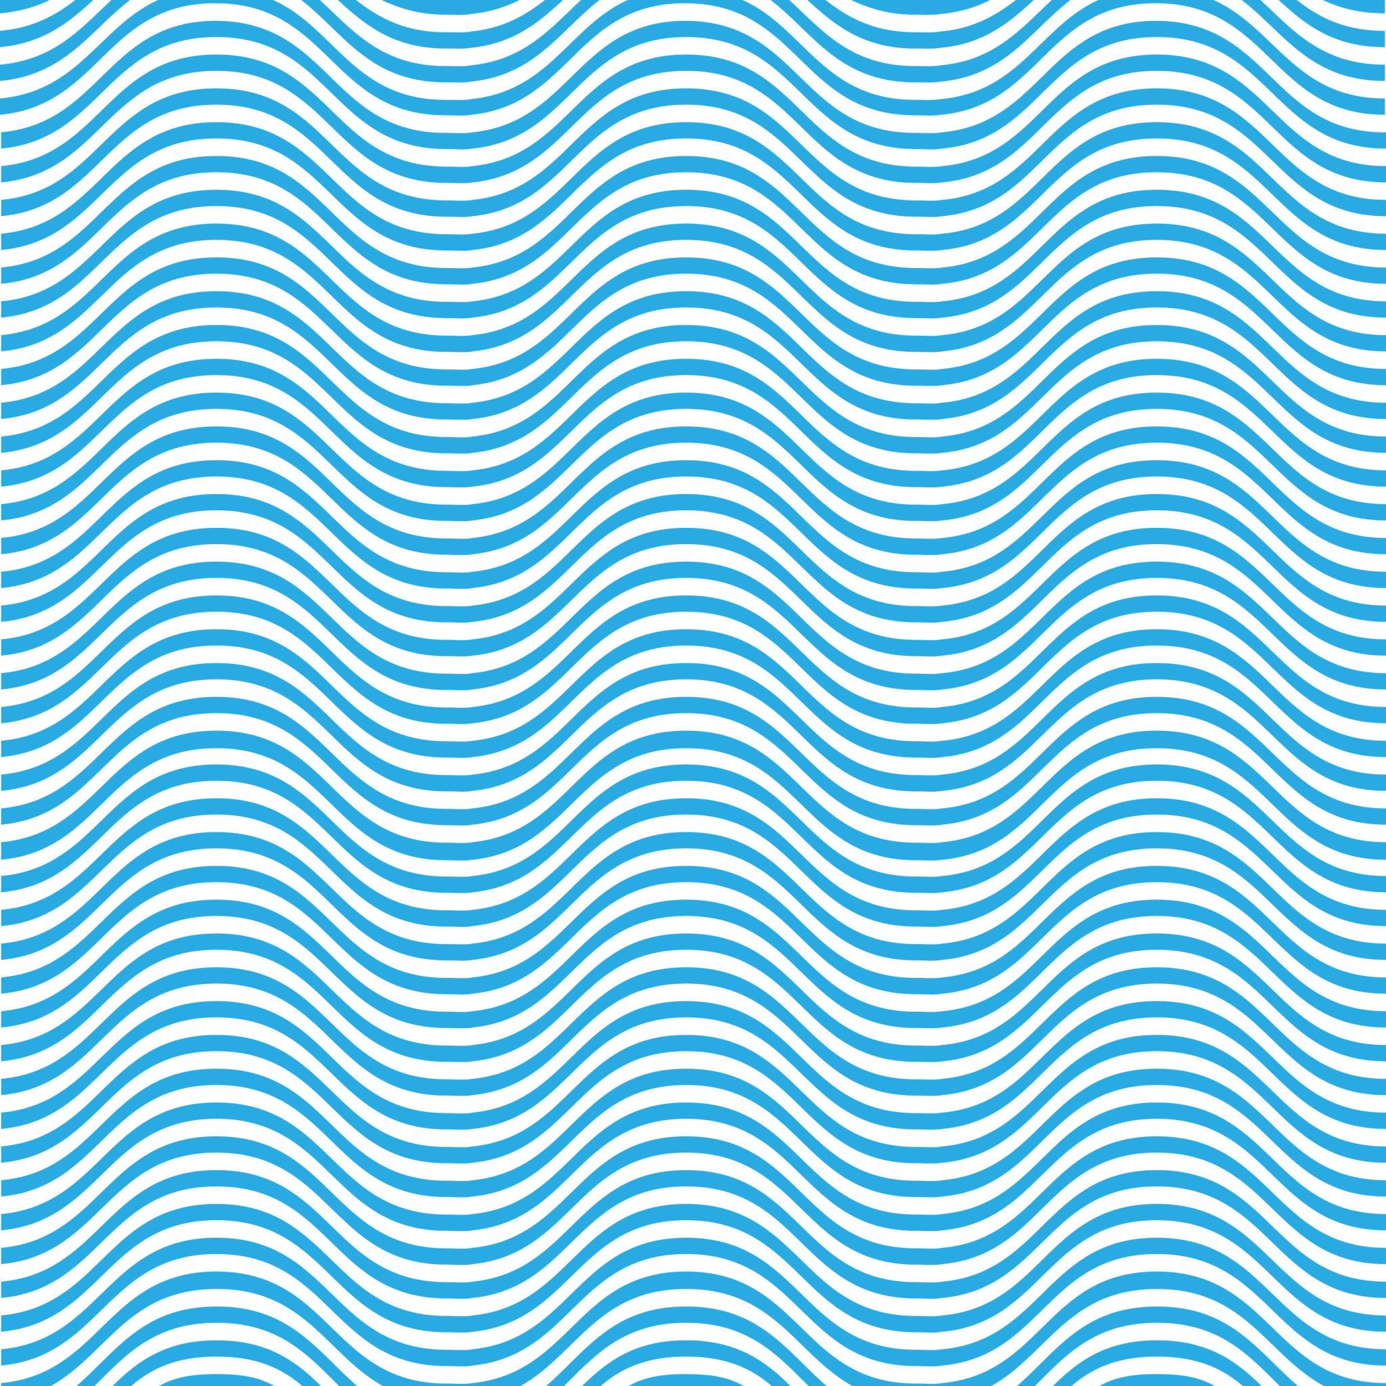
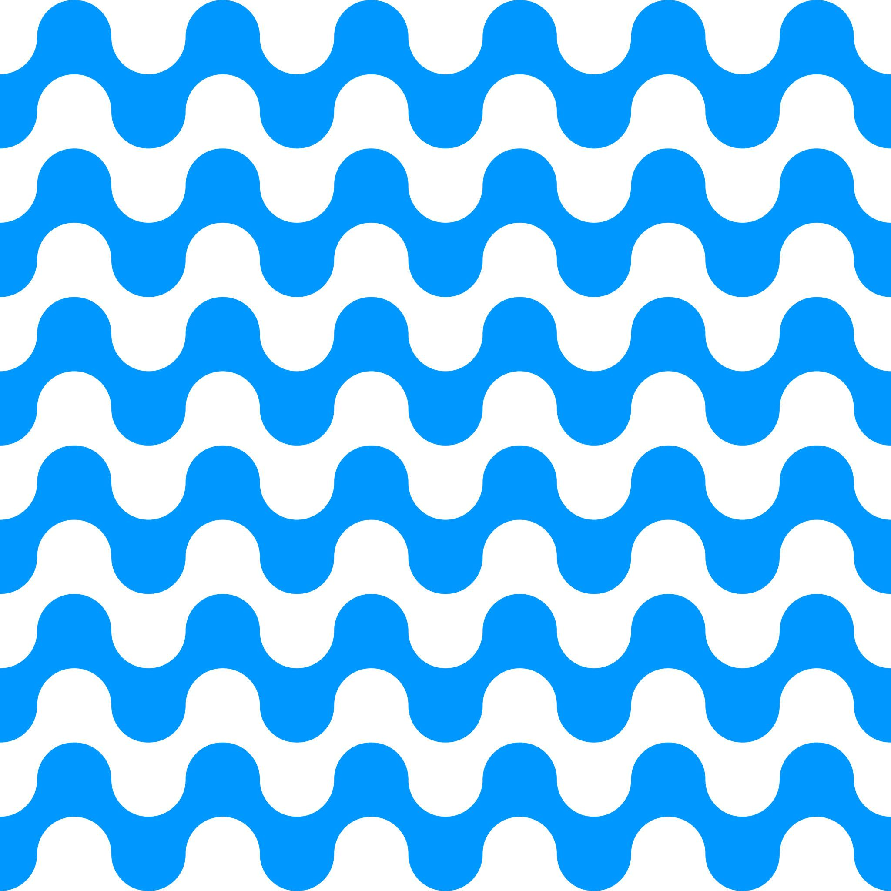
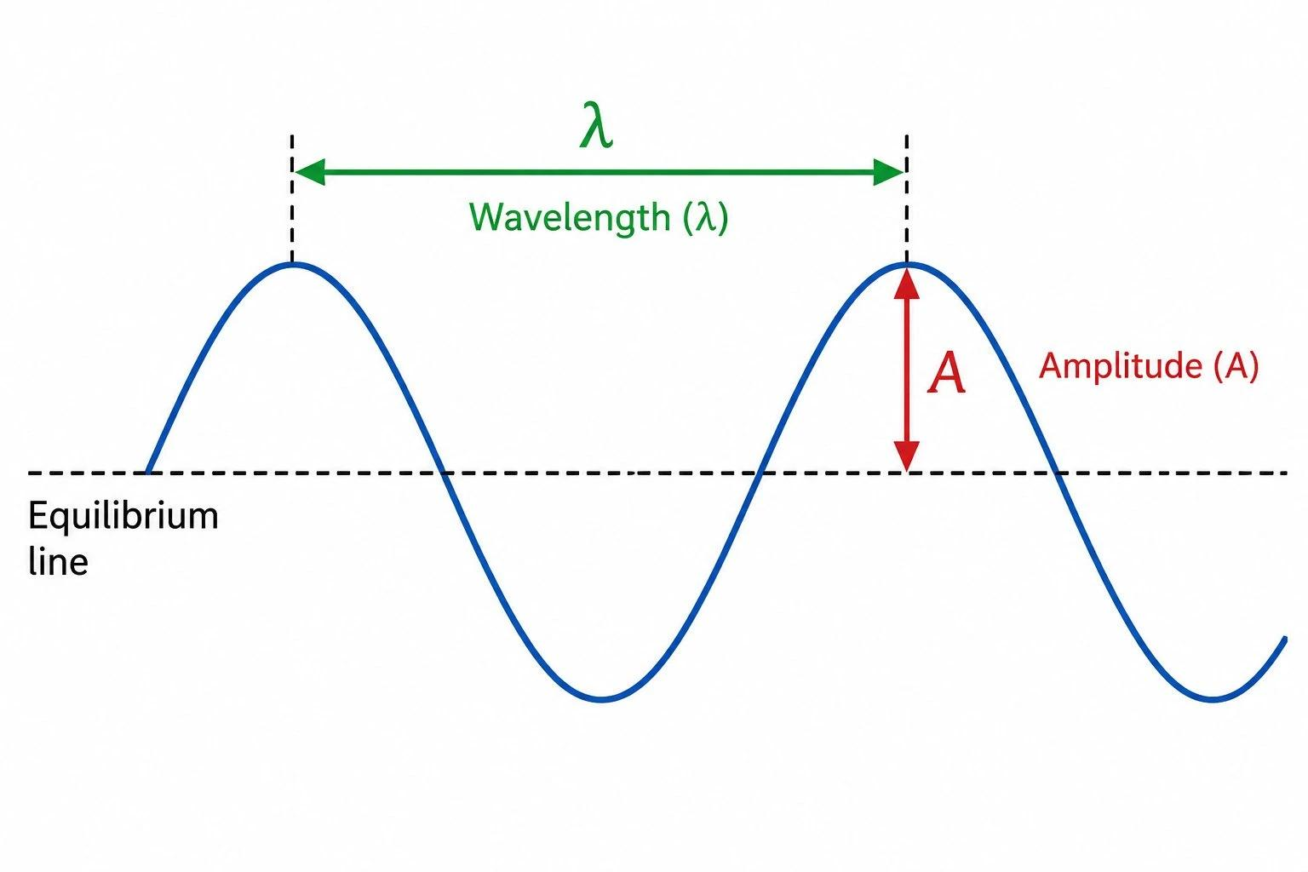


Mathematical Properties

Amplitude
# Source: AI Source: Provided by: [Data Path: Persons Table -> ID Column: 1, Name_En Column: Motasem Essam] -> From: [ChatGPT] on [7/25/2026]
For
$$y=Asin⁡\left(Bx+C\right)+D$$
the amplitude is
$$∣A∣$$
It represents the maximum displacement from the midline.

Period
# Source: AI Source: Provided by: [Data Path: Persons Table -> ID Column: 1, Name_En Column: Motasem Essam] -> From: [ChatGPT] on [7/25/2026]
The period is
$$T=\frac{2π}{∣B∣}$$
It represents the horizontal distance required for one complete repetition.

Frequency
# Source: AI Source: Provided by: [Data Path: Persons Table -> ID Column: 1, Name_En Column: Motasem Essam] -> From: [ChatGPT] on [7/25/2026]
The frequency is related to the period by
$$f=\frac{1}{T}$$
A higher frequency produces more repeated waves over the same interval.

Wavelength
# Source: AI Source: Provided by: [Data Path: Persons Table -> ID Column: 1, Name_En Column: Motasem Essam] -> From: [ChatGPT] on [7/25/2026]
For a spatial wave, the wavelength is the distance between corresponding points of consecutive waves, such as:
- Crest to crest.
- Trough to trough.
For a standard sinusoidal representation:
$$λ=\frac{2π}{∣B∣}$$
when $x$represents spatial distance.

Regular vs Irregular Wavy Shapes
# Source: AI Source: Provided by: [Data Path: Persons Table -> ID Column: 1, Name_En Column: Motasem Essam] -> From: [ChatGPT] on [7/25/2026]
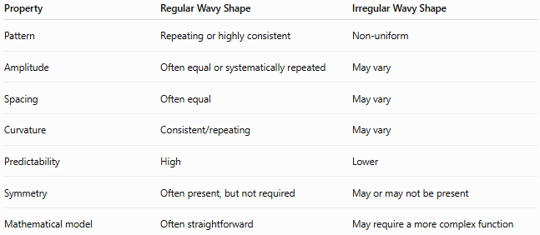
Property | Regular Wavy Shape | Irregular Wavy Shape
Pattern | Repeating or highly consistent | Non-uniform
Amplitude | Often equal or systematically repeated | May vary
Spacing | Often equal | May vary
Curvature | Consistent/repeating | May vary
Predictability | High | Lower
Symmetry | Often present, but not required | May or may not be present
Mathematical model | Often straightforward | May require a more complex function
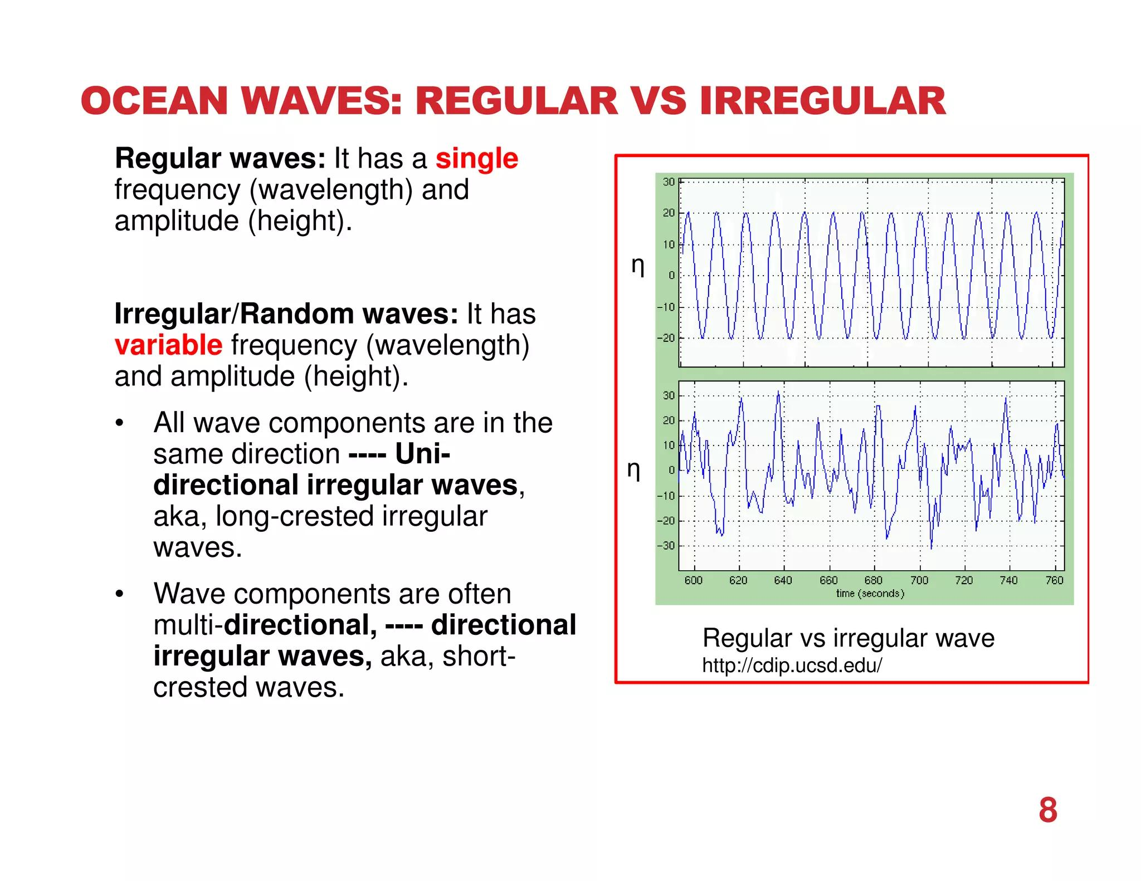
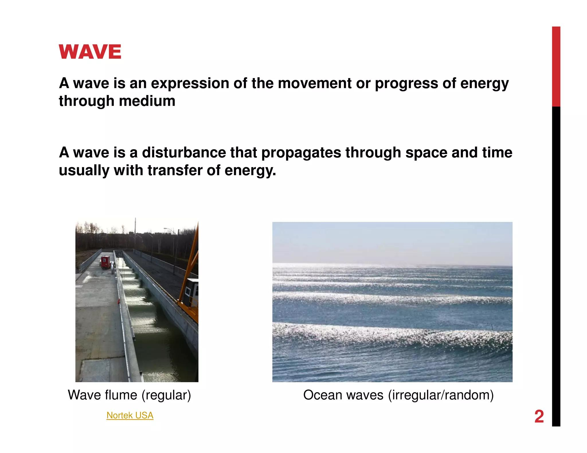

Regular Wavy Shapes vs Zigzag Shapes
# Source: AI Source: Provided by: [Data Path: Persons Table -> ID Column: 1, Name_En Column: Motasem Essam] -> From: [ChatGPT] on [7/25/2026]
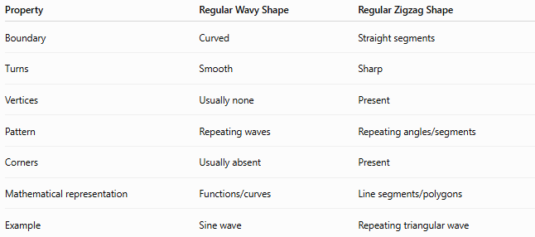
Property | Regular Wavy Shape | Regular Zigzag Shape
Boundary | Curved | Straight segments
Turns | Smooth | Sharp
Vertices | Usually none | Present
Pattern | Repeating waves | Repeating angles/segments
Corners | Usually absent | Present
Mathematical representation | Functions/curves | Line segments/polygons
Example | Sine wave | Repeating triangular wave
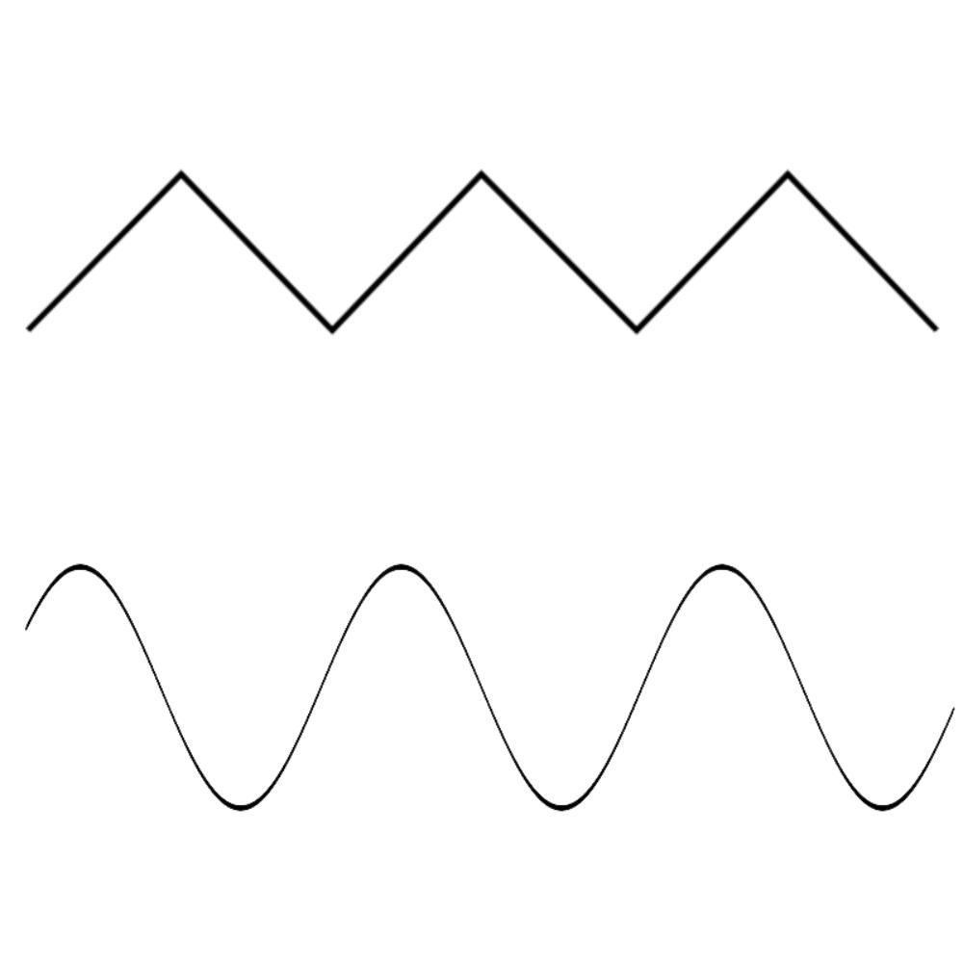
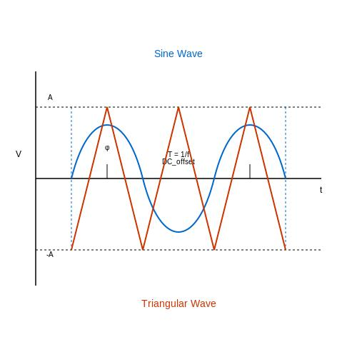
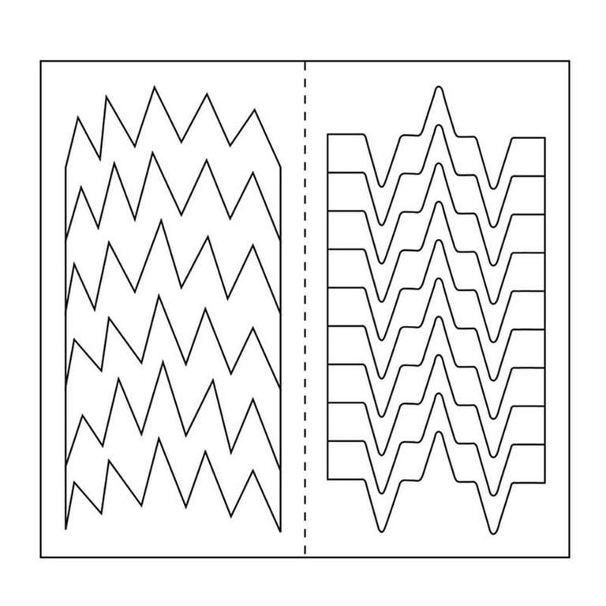
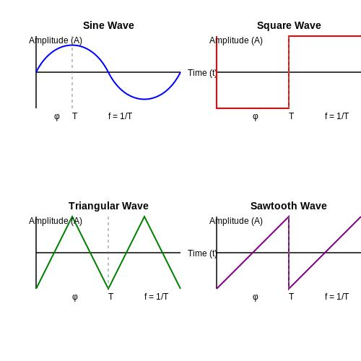

Examples
# Source: AI Source: Provided by: [Data Path: Persons Table -> ID Column: 1, Name_En Column: Motasem Essam] -> From: [ChatGPT] on [7/25/2026]
Examples of regular wavy shapes include:
- A sinusoidal curve.
- A repeating sine-wave boundary.
- A regularly spaced series of smooth waves.
- A closed radial wave with equally repeated lobes.
- A symmetric decorative wave pattern.
- A regular periodic curve.
- A multi-wave boundary with equal amplitudes and wavelengths.

Classification Summary
# Source: AI Source: Provided by: [Data Path: Persons Table -> ID Column: 1, Name_En Column: Motasem Essam] -> From: [ChatGPT] on [7/25/2026]
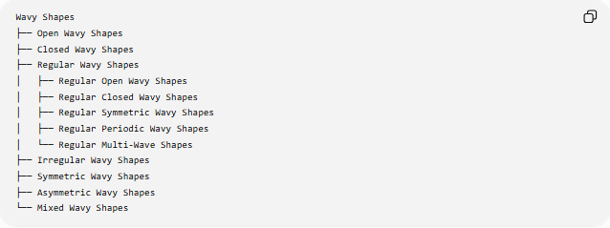
Wavy Shapes
├── Open Wavy Shapes
├── Closed Wavy Shapes
├── Regular Wavy Shapes
│ ├── Regular Open Wavy Shapes
│ ├── Regular Closed Wavy Shapes
│ ├── Regular Symmetric Wavy Shapes
│ ├── Regular Periodic Wavy Shapes
│ └── Regular Multi-Wave Shapes
├── Irregular Wavy Shapes
├── Symmetric Wavy Shapes
├── Asymmetric Wavy Shapes
└── Mixed Wavy Shapes
Important: These categories can overlap. For example:
A shape can be simultaneously a Regular + Closed + Symmetric Wavy Shape.

Key Points
# Source: AI Source: Provided by: [Data Path: Persons Table -> ID Column: 1, Name_En Column: Motasem Essam] -> From: [ChatGPT] on [7/25/2026]
- A Regular Wavy Shape has a consistent or repeating wave pattern.
- Regularity is primarily about uniformity and repetition.
- It does not necessarily mean that the shape is mathematically "regular" in the strict polygon sense.
- Regular wavy shapes can be open or closed.
- They can also be symmetric or asymmetric.
- Sinusoidal functions provide an important mathematical model for regular wavy patterns.
- For a sinusoidal function, amplitude controls wave height while period controls repetition.

Conclusion
# Source: AI Source: Provided by: [Data Path: Persons Table -> ID Column: 1, Name_En Column: Motasem Essam] -> From: [ChatGPT] on [7/25/2026]
A Regular Wavy Shape is a wavy form characterized by a consistent, repeating, or systematically organized pattern. Its regularity can arise from equal amplitudes, equal spacing, repeated curvature, periodicity, or other consistent geometric features. Unlike a regular polygon, however, regular wavy shape is primarily a descriptive classification rather than a strict universal mathematical category.

